On the empirical econometric estimation of CES energy-augmented macroeconomic production functions

**Highlights (*5x85 char max*)**

* Macroeconomic Production Functions (MPF) remain heavily criticised
* Yet MPFs are becoming more central to economic and energy policy
* In particular, energy augmented CES functions are increasingly used
* Yet guidance on their empirical use is relatively scarce and disparate
* This paper reviews aspects of empirical energy-augmented CES studies
* Friendly reviewers options (at draft Working paper stage): David Stern; Jeroen van Den Burgh, Taoyaun Wei, Harry Saunders
* Quotes (*in italics*) – easier to see how many there are (too many), and will be removed later
* Possible journals: generalist audience (lower impact factor) *Energies*
* Version 2.0; 26 May 2015
* Wordcount (v2.0) = 7400 words

Abstract

Macroeconomic production functions are a core part of growth accounting. Importantly, their use has evolved from largely academic debate to real-world applications, and now underpin economic models used to form policy. The two most common forms are the Cobb-Douglas (C-D) and the Constant Elasticity of Substitution (CES) functions, historically using just two input production factors: capital and labour. The recent importance of energy and emissions related national policies means energy is now more commonly added as a third production factor, to enable empirical studies to consider questions including macro-economic energy rebound, the contribution of energy to Total Factor Productivity, and climate and economic implications of energy transitions. At the same time, empirical evidence, coupled to increased computational ability, is driving a switch from C-D to CES functions.

Taken together, these aspects explain the recent rise of energy-augmented CES functions in academic and real-world arenas. However, guidance on their use of is relatively scarce and disparate. This paper seeks to address this literature gap, by collating the various issues relating to their specification (e.g. choice of variables, nesting) and then implementation (e.g. solution technique, statistical testing of results). The overall aim is to collate best-practice and serve as an aide-memoir to those who intend to use energy-augmented CES functions for empirical analysis.

# Introduction

## The issue

Macroeconomic Production Functions (MPFs) seek to explain economic outputs from a series of aggregated inputs, and are “*an important instrument in [Government] economic forecasts and policy*” (1). We classify three types of application within our MPF definition: aggregate production functions - which use national-scale values to model the entire economy (e.g.(2–4)) sectoral production functions which examine sectors in isolation (e.g.(5,6)); and sectoral production functions within a whole economy general equilibrium (e.g. CGE) framework (e.g. (7,8)). The two most common types of MPF – as we see later - are the Constant Elasticity of Substitution (CES) and Cobb-Douglas (CD) functions.

Four linked issues provide the rationale for this paper. First, the application of MPFs has spread beyond economics to include energy and emissions policy. This has led to a renaissance of energy-augmented MPFs - originally marginalised or rejected on a ‘cost-share theorem’ (9) basis – to examine energy-related questions including macro-economic energy rebound (10,11), the contribution of energy to Total Factor Productivity (12), and climate and economic implications of energy transitions (4,13). Second, an empirical switch is underway from CD function to CES functions. Third, combining these aspects means a growing use (and importance) of energy-augmented CES-based MPFs, but they are being undertaken using a variety of assumptions and solution techniques. Fourth, the growing importance of empirical CES energy-augmented MPF studies is supported by a somewhat disparate set of guidance and discussion, with different aspects of their theory and application covered by authors including Saunders (14), Henningsen and Henningsen (15) Klump (16), Shen and Whalley (17), Stern and Kander (4), Zha and Zhou (18), and Temple (19).

And this gets to the crux of the issue: as a more powerful and sophisticated car (compared to CD equations), using energy-augmented CES-based MPFs for empirical research needs a more coherent owners manual, setting out the options and implications of choices that are made.

## Our response

In response, this paper seeks to set out - in accessible journal format - the main options and implications of choices involved in setting up and empirically solving energy-augmented CES based MPFs. We start in section 2 by reviewing the historical roots and dominance of CD and CES based MPFs. To provide guidance as to their current usage, a sample of empirical CES based MPFs studies are reviewed in section 3. Then we examine the empirical specification and solution in three parts: Section 4 - Specifying the CES Function parameters; Section 5 – finalising the CES equation, and Section 6 – statistical testing. Conclusions are provided in Section 7.

# Background

## Historical roots

Lloyd (20) suggests the C-D origins can be traced to von Thünen in the 1840s and Wicksell c. 1900, well in advance of the 1928 Cobb-Douglas formulation (21) shown in Equation 1. In a Cobb-Douglas equation, the elasticity of substitution between production factors (e.g. from labour to capital) is assumed to be unity. To overcome this significant constraint, the CES function was developed to provide flexibility for the elasticity of substitution (sigma), as the Arrow et al (22) formulation in Equation 2 and Equation 3 shows:

|  |  |  |
| --- | --- | --- |
|  | Equation 1 | Y = (economic) Output  A,C = constants  K = Capital  L = Labour  a = output share of capital  1-a = output share of labour  λ = Solow Residual (gain in total factor productivity)  α = elasticity of output (Y) w.r.t. Capital  β = elasticity of output (Y) w.r.t. Labour  ρ = a substitution parameter  ν = variable returns to scale parameter  σ = the elasticity of substitution |
|  | Equation 2 |
|  | Equation 3 |

MPFs are applied, empirically, at economy-wide scale by estimating values for the unknown parameters to obtain the best possible fit against historical economic output (Y). Solow’s 1957 study of the US (2) using the C-D function “*was a landmark in the development of growth accounting*”(23), and was followed in the 1960s by others including Arrow (22), Denison (24) and Jorgenson (25). Empirical MPF applications typically examine issues including substitution or price elasticities (10,26,27); assigning growth to technical change and factors of production (28–31); and addressing policy issues (13,32).

Conventional growth theory ascribes economic expansion to the two canonical factors of production: capital and labour, and any additional growth (or decline) is assumed to be caused by exogenous factors (e.g. innovation) and wrapped up in total factor productivity (TFP). Many studies ascribe to this model (3,30,33). However, researchers – famously including Solow (2) - commonly find capital and labour only explains a minority of economic output compared to the exogenous Solow Residual term (the change in TFP). Researchers have been working on TFP and the Solow Residual for over 50 years, including Jorgenson (25), Denison (34) and Hulten (35). To attempt to reduce the exogenous term and explain more of economic output from within the model, quality adjusted values of capital and labour (36–38) have been used, as well as additional factors of production, such as energy (39–41), materials (42,43) and money (44,45).

## Macroeconomic production functions are hardy plants

MPFs are not without criticism. Mishra (46) notes that the aggregate production function has been “*the most turbulent area of research in the economics of production*”. Critiques – especially for the CD function – exist on three fronts. First is that the factors of production typically explain only a small part of economic growth, with the remaining high Solow Residual being attributed to exogenous technical change, leading Solow (2) to remark “*it takes something more than the usual “willing suspension of disbelief” to talk seriously of the aggregate production function”.* Second, are theoretical concerns: Joan Robinson (47) was among a group involved in the 1950s-1970s Cambridge-Capital controversy, who stated capital could not be measured, thereby invalidating the use of production functions. Meanwhile Fisher (48) suggested the neo-classical constraints on the aggregation of firm level production functions are impossible to hold at a national scale. Third – led by Anwar Shaikh’s (49) HUMBUG critique in the 1970s - is that the C-D function is just an accounting identity, which explains the commonly observed correlation R2 coefficients of over 0.99 (e.g.(30,33)). Mishra (46) suggests these criticisms “*should have ousted the Cobb-Douglas production function from all serious endeavors in economic analysis”.* Later, Felipe and McCombie extended the accounting identity argument to include the CES function (50).

## The dominant species: CD and CES functions

### Google-Scholar search

And yet, despite these serious flaws, “*economists have continued using the aggregate production function in both theoretical and applied works*” (51). Miller (1) gives a practical reason: “*even if* *our model is misspecified and the parameters are in fact statistical artifacts, they may still be useful for forecasting purposes*”. Indeed, the popularity of MPFs seems to be flourishing as illustrated by Figure 1 and Figure 2, which show the reference to a defined list of common production functions according to a Google-Scholar search[1], which is a simple metric to provide guidance on relative use of different approaches, and is not intended to be a full systematic review.

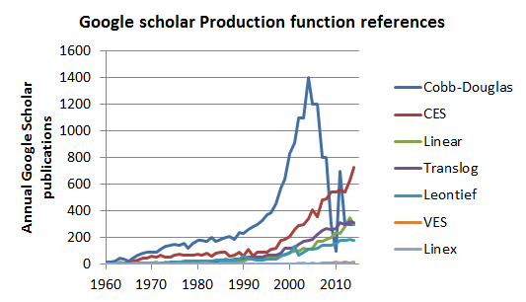

Figure 1: Google-Scholar annual publications that reference each production function

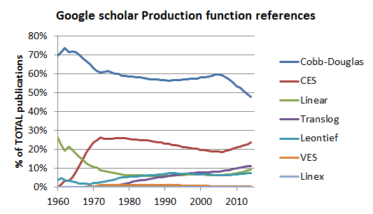

Figure 2: Google-Scholar % of total cumulative publications that refer to each type of production function

Figure 1 and Figure 2 supports the assertions of various authors including Miller and Felipe (e.g. (1,52)) that the easy-to-use C-D function is historically the most popular, but also provides evidence that the CES function is increasing in recent popularity. (We should note here that the C-D function is a reduced CES function, with elasticity of substitution set to 1.0) As Temple (19) comments, “*the CES production function is increasingly prominent in macroeconomics and growth economics*, whilst Chirinko (26) notes salient titles of conferences such as “*A Bright Future at the Age of 50 – The CES Production Function In the Theory and Empirics of Economic Growth”*.

### An energy–augmented renaissance

It is relevant at this point to introduce the energy-augmentation of the CES and CD functions. Energy-augmentation for the C-D function takes the form of Equation 4. For the CES function, various nestings of energy against capital and labour are possible. Equation 5 shows one option, the (KL)E nesting.

|  |  |
| --- | --- |
|  | Equation |
|  | Equation |

It is not a new idea, and was prominent after the 1970s oil crises, e.g. Rasch and Tatom 1977 (39). As energy prices declined so too did the idea of energy-augmentation, which was dismissed on the cost-share theorem (53) - which suggested that energy’s share of the total GDP (typically 3-4%) was so low it could not be a meaningful factor of production. However, leaving production functions to one side, a large body of statistical work (e.g. (54–56) has emerged in the last two decades which suggests a strong link between economic growth and energy use. This, alongside rising energy costs and requirements for energy and emissions policies, has seen a renaissance of energy-augmented functions.

# Real-world empirical MPF applications for CES functions

In this section we review the various applications for empirical MPF applications of CES functions. We start with a sample survey, and then move a wider literature search.

## Sample survey

If CD and CES are indeed the dominant functions, we next need to understand how they are used, in particular for the CES function, the object of our study. To do this, we studied a small sample of the Google-Scholar references – since the number was around 40,000 - to understand better the application of purpose of CES (and CD) applications. We reviewed 29 CD and 17 CES based studies (3,5,29,30,32,33,36–41,43–45,57–87), as detailed in Appendix A. We endeavoured to ensure that these (largely empirical) sample papers were representative of the larger Google Scholar results as follows: first ensure the correct CES and CD proportions for each decade, second constrain search results to each decade, third select empirical CES and CD papers based on highest returned relevance. Whilst a small sample may exhibit selection bias, its aim is purely as a guide as to the sort of empirical studies that are undertaken.

The primary motivation of the sample studies is reported in Figure 3, with analysing changes in Total factor Productivity (TFP) – i.e. the Solow Residual - the most common reason, followed by the testing of a new variable within the production function. However, this is largely driven by the CD studies. For the CES studies, the focus appears more practical: i.e. the elasticity of substitution (required as inputs for CGE models) and aspects of computational solving (e.g. R). Other comparative characteristics (e.g. factors of production; solution method; and treatment of Solow and fitted residuals) between the two dominant MPFs are shown in Appendix A.

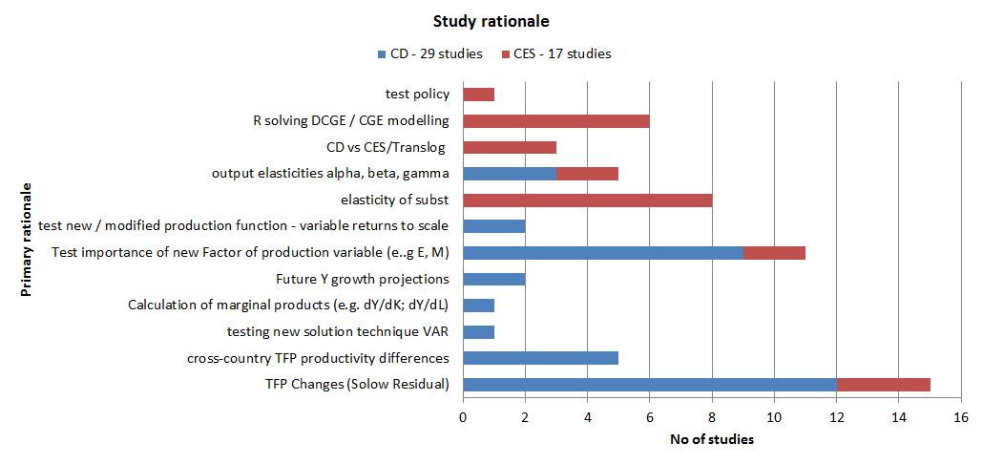

Figure 3: Primary motivation of the study samples

It is also useful to gauge what are the key variables considered in the sample. In Figure 4, we see the main variables in our sample papers were Y (constant prices) and basic unadjusted factors of production: Manhours (L); capital stock (K). Agriculture-based factors of production (i.e. land, fertiliser, feed) were part of the original idea of production functions (20), and the samples suggest they remain in use (e.g. (58–60,65,71)). Also from the sample, energy appears in the late 1970s post oil-crises (39,40), and reappears from the mid 1990s ((5,32,63,70,80,85). Either primary energy (E) or quality (price) adjusted E is part of the energy-augmented studies. Materials are included as part of a K-L-M (42) or K-L-E-M ((43) framework.

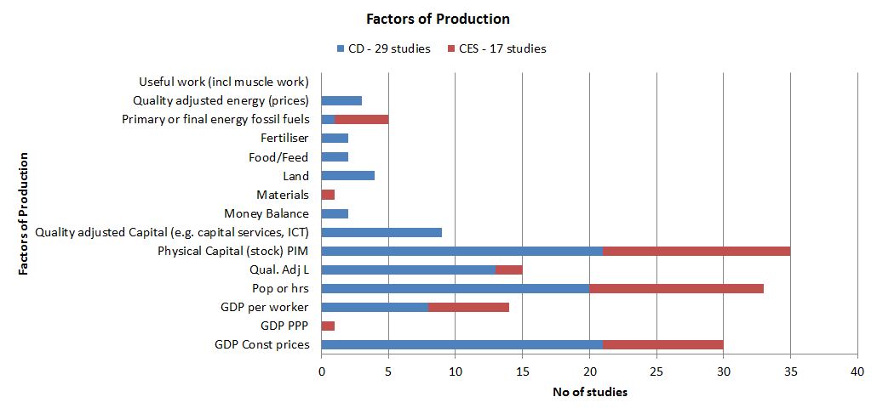

Figure 4: output variable (Y) and factors of production in the CD / CES sample papers

## Wider literature evidence

Next we need to cross-check this sample against evidence from the wider literature. Firstly, the sample view that general equilibrium (GE) models are an important application of MPFs seems supported by the wider literature. As the elasticity of substitution is an important GE model variable, models typically use CES equations, such as GTAP ((81), WITCH(88), and other authors ((8,15,89,90). DSGE models also use CES functions ((86,91). Some models are CES based but also include CD elements/modules ((7,92,93). Commonly the use of general equilibrium models assess impacts on policy, such as Turner (94) and Bor and Huang (8). An excellent review of this is considered by Van der Werf (32).

The elasticity of substitution (σ) plays a central role in understanding economic growth, as highlighted by Chirinko (26) and Palivos (27). Much effort is therefore put into empirical analysis using CES functions to estimate elasticity of substitution values, which in turn can be then used for inputs to models. Studies either focus on substitution elasticities for capital-labour (e.g. La Grandville and Solow (95) and Guo and Lansing (96) or capital-labour-energy (e.g. Kemfert (80), Koesler and Schymura ((43), Dissou et al (5); Shen and Whalley ((17); Smyth et al ((6); Zha and Zhou (18) and Koetse et al ((97)).

Comparison between CES and CD results appears an important aspect. This can be for cross country comparisons (e.g. Duffy and Papageorgiou (83)); specific countries (e.g. Bonga-Bonga ((82)) or sectors (e.g. Ravel (98) or business cycles (86). What is revealing is that these studies typically report that CES is preferable and CD should not be used. Comparative reports are also of interest, e.g. Miller ((1)).

Also relevant is the origin of the studies: this is no longer an academic playground, there are a wide variety of government agencies and banks that publish or fund the work. These include US Congressional Budget Office (1); US Census Office (98); European Central Bank (99); US Reserve Banks (29,31); OECD ((100); UK Office for National Statistics (37); Bank of England (28) New Zealand treasury (84) and Bank of Poland (101).

The increased use of general equilibrium models has in turn led to detailed guidance from textbooks on the use of CES functions in a general equilibrium modelling framework, e.g. Hunt and Evans (102); Cardenete et al (103) and Kreinin et al (104). Some work published relates to the documentation for certain models e.g. GTAP (81), Penn World Tables (105), HMRC’s CGE model (106) and DSGE model for the US Federal Reserve (107) and European Commission (108).

Finally, the recent importance of energy-related national policies means that energy is a common additional term in MPFs to study energy-related questions including macro-economic energy rebound (10)(11), the contribution of energy to Total Factor Productivity (12), and climate and economic implications of energy transitions (4,13).

## The research gap: the rise of empirical CES energy augmented MPFs and the need for discussion of key issues

Three features emerge from our sampling and literature review. First the trend for increasing quality adjustment to the factors of production, second the growing inclusion of energy as additional variable (particularly in general equilibrium modelling), and last the move away from CD to CES functions. The studies reviewed suggest this switch to CES functions is due to numerous factors: the renewed theoretical CD critique by Felipe et al (e.g.(109)); the empirical studies which conclude CES gives better results than CD (e.g. (83,84,86)); the studies which estimate elasticity of substitution values (e.g.(17,80)) - which de facto requires a CES (rather than CD) approach; their increasing use in real-world economic models for central bank (84,99) and policy applications (85,86); and the availability of increased computing power and analysis programs (15,81).

Bringing these strands together, we arrive at our start point: energy-augmented CES functions are increasingly being used for empirical analysis, yet they are often mis-specified, mis-used or mis-interpreted. As we see later, the key issues relate to the specification of the CES function or in the solution techniques, issues which are compounded by adding energy as a factor of production. Whilst some guidance does exist for specification and calibration of CES functions in journals, typically it refers only to certain aspects, such as rebound (14), normalisation (19), or taxation (89). Therefore this paper aims to provide a current, consolidated summary of main issues for the empirical use of CES energy-augmented MPFs. It is not meant to be prescriptive, but instead intends to set out the key issues coupled to their options and implications.

# Issues, Options and Implications I – Selecting the CES function parameters

## The CES equation

We now expand Equation 5 to include input productivity coefficients τi, and convey the three different nesting types KL(E), KE(L) and EL(K), as shown in Equation 6, Equation 7 and Equation 8 respectively:

|  |  |
| --- | --- |
|  | Equation 6 |
|  | Equation |
| λ = Solow Residual (gain in total factor productivity)  = a substitution parameter  = the elasticity of substitution  = productivity coefficient  = variable returns to scale parameter  Where: | Equation |

We need to define an equation for SR

Edenhofer et al (110) presents an example of a non-nested CES function in Equation 9. However, various authors (e.g.(18,32,111)) report these are less commonly used, and so are not considered further here.

|  |  |
| --- | --- |
|  | Equation |

## Economic output (Y)

On the surface, it seems straightforward to select economic output (the dependent variable, Y) as Gross Domestic Product (GDP). However, three decisions need to be made before arriving at a selection, and each step will result in different parameter solutions. The first is whether to use GDP (e.g. (5,85)) or Gross Value Added (GVA) (e.g. (32), (112), (113)) as the measure of the contribution of producers and economic sectors to economic output, though Szeto ((84) considers both. In theory GVA is more accurate, since is sums the total economic contribution of each sector, before the distorting effect of subsidies and taxes.

The second choice is whether output is in (more common) constant prices (e.g. (33,38,41,75)) or Purchasing Power Parity (PPP) prices (e.g.(32,84)). Since PPP places a higher weight on GDP in non-OECD countries - e.g. one $US Dollar in China buys more goods than in the US - PPP is useful in cross-country studies, by providing a more level playing field for comparisons.

The third choice is whether to use aggregate (Y) values (e.g.(17,82,114)) or output per worker (Y/L) values (e.g. (30,69,73,76,83). In the latter case Equation 5 becomes Equation 11. The choice of is influenced by the motivation for the study: gross output (Y) studies help understanding individual countries economic behaviour (such as elasticity of substitution, emissions and modelling (e.g. (82,84,85)); whilst output per worker (Y/L) studies aid inter-country (e.g.(79,83)) or regional/sectoral comparisons (e.g. (74,76)).

|  |  |
| --- | --- |
| Where  ; ;; | Equation |

### Basic (unadjusted) factors of production (K, L, E)

By unadjusted factors of production, we mean capital stock (K), labour (L) and primary energy (E). Capital stock (the estimated market value of total capital stock) is most commonly derived via the Perpetual Inventory Method (PIM), where an assumed initial capital stock valuation changes each year via additions (new stock) minus subtractions. Gross capital stock (GCS) defines subtractions as retirements of existing assets; whilst Net Capital Stock (NCS) = GCS minus depreciation of existing assets. NCS studies appear more common (e.g.(75,100) versus GCS studies (e.g.(32,39)), and are supported by internationally available datasets (e.g. The Organisation for Economic Cooperation and Development (OECD) and Penn World Tables (PWT)). The choice of capital stock variable should be aligned to output, i.e. in PPP, current or constant prices.

For labour, three options for unadjusted values of workforce labour exist in order of preferability: manhours (e.g. (39,74)), numbers of workers (e.g. (98)(17)), or lastly population can be taken as a proxy for labour input (e.g.(87)). Manhours are now commonly available via international datasets such OECD and PWT.

Primary energy (measured in energy units as the calorific content of the energy source in million tonnes of oil equivalent [Mtoe] or terajoules [TJ]) is the most common variable for energy. Primary energy data are annually published by national government agencies (e.g.(115)) and international organisations such as British Petroleum (116) and the International Energy Agency (IEA).(117).

Overall, these unadjusted variables remain very popular for empirical production function analysis, due to the good availability of datasets across countries and time-series, including Penn World Tables OECD and the IEA.

### Quality adjusted factors of production (K*, L*, E*)

Quality adjusted values for capital (K*), Labour (L*) and energy (E*) seek to better represent the productive effect of the basic inputs (K, L, E) on economic output (Y).

Starting with capital, quality adjustment is in terms of capital services, i.e. estimates the service that the stock makes. The common method is via capital rent: calculating the equivalent rent that would be paid for the asset, which provides a higher weighting for short-lived assets such as ICT, which are otherwise penalised versus longer lived assets like roads. Studies include Schreyer (100) and The Conference Board (72). Capital utilisation is a less common alternative, which estimates variations in utilisation of capital equipment according to economic cycle, as shown in Paquet and Robidoux’s Canadian study (118).

Second, quality adjustment of labour adds a weighting (human capital) factor for education. Examples based on schooling include Autor et al ((36) Dougherty and Jorgensen (64) and Daude (73). Including more skill-based components are less common, though Nilsen et al (119) provide one case study. Quality adjusted labour is more widely used than quality adjusted capital or energy - for example, Feldstein (57), Daude (73) and Growiec (101) all used unadjusted capital stock with adjusted labour (no energy).

Third, quality adjustment of primary energy takes two basic forms is distinguished in 1990 by Berndt (120): First is the price based method (e.g.(121)) and second is the thermodynamic method (e.g. (122) where end useful work is used rather than input primary energy.

### Merits of quality adjustment

Caselli (69) provides an excellent reference for the merits of quality adjusted variables (labour and capital), whose aim is to more closely model economic growth from the inputs. Quality adjusted values augment unadjusted values (e.g. (100)), meaning these variables are able to bring more of economic growth within the function, and assign less to exogenous technical change (i.e. Solow Residual).

Using capital services data seems logical and desirable: overcoming capital stock issues such as the initial value problem of the PIM method (e.g. (69,123)) and biased estimates of multi-factor productivity (100). Efforts to produce consistent time-series of capital services are increasing, with the UK’s Office of National Statistics an example of a government agency developing capital services data to run in parallel to capital stock data (124). As such, their use and application in empirical CES studies seems to be increasing (e.g. (38,100)), However, whilst datasets are becoming more prevalent, some caution is needed - Inklaar (125) raises importance concerns about the accuracy of these capital services methodology, such that Inklaar and Timmer (105) later decide to keep capital stock data for the PWT rather than adopt capital service data.

Quality adjusted labour is the most consistent and widely applied methodology (of the three), with work by authors including Barro and Lee (e.g. (126)) and de Silva (127) to produce time-series data, meaning this an increasingly viable option for studies. The results matter: Duffy and Papageorgiou (83) find using human capital adjusted labour the elasticity of substitution (between labour and capital) was significantly above unity for the richest countries and significantly below unity for the poorest countries.

Concerning quality adjusted energy, few datasets exist – and no international datasets – leaving studies to typically derive their own quality adjusted values (e.g. Berndt (120) and Ayres and Warr (128)), which is time-consuming. The result is that most CES empirical studies continue to use primary energy (e.g. (32,85)).

Interestingly, empirical studies rarely quality adjust all variables. Koesler and Schymura (43) use unadjusted K,L,E values, whilst Shen and Whalley (17) use unadjusted K, adjusted L, and unadjusted E. This highlights a curious feature: studies involving just capital and labour expend significant effort to quality adjust normally one variable (occasionally both), but those introducing energy as a third variable typically use unadjusted values for capital and labour. This is slightly surprising, given the focus of the studies is to better model growth from within the model, but perhaps best reflects the effort involved in obtaining time-series quality adjusted variables.

## Other parameters

### Elasticity of substitution, σ

Elasticity of substitution (σ) tells us if one input decreases, how much is substituted by another. It is probably the single most important parameter to be evaluated from an empirical CES study, due to its importance in modelling and policy, as noted by authors including Zha and Zhou (18), Koesler and Schymura (43), Sorrell (129), and van der Werf ((32). A good discussion is also provided by Chirinko (26) and Palivos (27). It is a crucial parameter in a CGE modelling framework: Jacoby et al (130) found changes to this variable was the main driver of their CGEmodel results. Meanwhile Saunders (10,14) finds the parameter has a significant impact on energy rebound.

Reviews of substitution elasticities (including energy) include Van der Werf (32), Koetse et al (97) and Sorrell (129), all find a wide range of values reported in the literature. Indeed, despite the importance of the variable, relatively few, consistent estimates exist, which Koesler and Schymura (43) find “unsatisfying”. Possibly worse, Van der Werf (32) suggests “*in most applied dynamic climate policy models, neither the production structure nor the accompanying elasticities of substitution have an empirical basis*.“

Sorrell (129) widens the issue of this parameter further, when he notes firstly the confusion from the different definitions of elasticity, and secondly the most commonly calculated definition Allen-Uzawa elasticity of substitution (AES) e.g.(131–133) is of little use to CGE models, which actually require the Hick’s Elasticity of Substitution (HES) “*which measures the ease with which a decrease in one input (i) can be compensated by an increase in another (j) while holding output fixed”* (129)*.*

So this leaves little as a way forward. An off-the-shelf value - outwith the model - is most likely wrong, since it wont match the production structures or input data. The best way approach is to calculate it directly from the data, but note the calculated value will depend heavily on the estimation technique (Koesla and Schymura (43) criticise the linear estimation techniques of van der Werf (32), Kemfert and Welsch (85), plus it will vary depending on your nesting structure and definition of σ.

### Input productivity coefficients

The purpose of input productivity coefficients is to bring explanatory power within the function: to increase endogenous growth and reduce the exogenous Solow residual. It does the same job as the quality adjustment of variables: starting with the basic K, L, E it brings in additional factors linking to growth. Empirical research into productivity coefficients for labour and capital include Adetutu (134) and Schreyer (100), and for energy include Honma and Hu (135). International databases[2] are increasingly providing productivity values for capital and labour. In a production function context, various examples exist. Sancho (89) specifies αj as productivity parameter for each input, j. as shown in Equation 12:

|  |  |
| --- | --- |
|  | Equation 12 |

Saunders (14) introduces an energy efficiency parameter, τ, into the CES function as shown in Equation 13:

|  |  |
| --- | --- |
|  | Equation |

Cantore and Levine (136) introduce capital-augmenting (ZKt) and labour-augmenting (ZNt) technical change, as shown in Equation 14:

|  |  |
| --- | --- |
|  | Equation |

Saunders (10) provides a rare empirical CES study, defining , and as capital, labour and energy augmenting technical efficiency parameters, based on the Stern and Kander (4) study. As shown in Equation 15:

|  |  |
| --- | --- |
|  | Equation |

So in theory the productivity coefficients should be the same as the quality adjusted variables, but comparable studies have not (to our knowledge) been undertaken. The choice, of whether to take this productivity approach, or quality adjusted values K*, L*, E*, may be simply down to availability of data.

### Total factor productivity coefficients

The expansion of this approach considers exogenous productivity (i.e. total factor productivity change) as an input variable to the analysis, as given by Chang (131) and Prywes (132), in which case Equation 6 becomes Equation 10. However, such an approach is rarely employed – more often total factor productivity change (i.e. the Solow Residual) is a desired output from the analysis.

|  |  |
| --- | --- |
| Where:  = Total factor productivity change term | Equation |

### Returns to scale, ν

There are two reasons why empirical CES studies almost exclusively assume unity returns-to-scale value (ν = 1.0). First, is that studies simply follow this most basic economic convention, as Chang (131) notes “*extreme increasing or decreasing returns to scale would be difficult to rationalize, this paper assumes constant returns to scale*”. Second, since most economic models also use this assumption (plus others such as perfect competition), there is little ‘pull’ for empirical CES studies to change, leaving the parameter, ν, set as unity.

As such, it is rarely tested in empirical CES studies. However, some studies do – at least temporarily - relax this parameter, such as Szeto’s New Zealand study (84), who despite finding a returns-to-scale value of 1.094 – significantly above unity, returned to ν = 1.0 since “*As theory suggests that there are constant returns to scale in production, we will impose this restriction in the remainder of our empirical analysis”.* Duffy and Papageorgiou (83) adopt a similar philosophy, running an unrestricted analysis to find ν=0.97-1.00 depending on choice of labour input, then restricting ν = 1.0 for the rest of their paper.

Therefore, if the purpose of the study is purely empirical, it seems sensible to first run an unrestricted analysis, and then re-run with restricted parameters (e.g. returns-to-scale = 1.0). This will give two different solutions, and permits the review of how well the model supports the unity returns to scale assumption. Ultimately though, if the purpose is to feed parameter values into an economic (e.g. CGE) model, then the assumption should match that of the model, which typically is ν = 1.0.

# Issues, Options and Implications II – Finalising the CES function

Having determined the parameters, decisions on nesting and normalisation are required, prior to solving the function.

## Nesting (K,L,E)

The three possible nests of the CES equation: KL(E), KE(L) and EL(K), were given earlier in Equation 6 to Equation 8, with a sample schematic diagram of a KE(L) nest in Figure 5:



Figure : KE(L) nesting, taken from Lecca et al (111)

Lecca et al (111) consider this issue in detail, noting *“Nested CES production functions are commonly used in CGE models in general … and specifically in energy/ environmental CGE models”*. Nesting is important since it affects where energy enters the production structure, and thus the values of output solution parameters, such as the elasticity of substitution. Van der Werf (32) reviews production functions used in climate-based models (i.e. KLE or KLEM models) and finds considerable variation in nesting structure. He finds the most commonly applied nest is KL(E), which is supported by Zha and Zhou (18) who note *“until now the (KL)E form appears to be the most widely used version, such as the WITCH model* (88)*, MERGE model* (137) *and MIT’s EPPA model* (130)*”.* Interestingly, the KL(E) format appears not only the most commonly applied, but is considered by Saunders (14) to be the only nesting structure that is sufficiently rebound flexible.

In terms of nesting in practice, there are three options. First, decide a single nesting structure, based on theoretical (e.g. energy rebound is important, so restrict the analysis to KL(E)) or other considerations. Examples include Saunders (10). Second, let econometric cointegration decide the most statistically likely structure, such as Bonga-Bonga (82), and then analyse that structure. Third, report results from all three types of nest, though Dissou et al (5), Kemfert (80) and van der Werf (32) provide rare (somewhat curiously) examples. Sensitivity analysis can then be done on the three types of nesting, as Lecca et al (111) did.

## Normalisation

The final issue before solving the function, is whether to normalise the input data, as advocated by La Grandville, Klump, and co-authors (e.g.(16,95,99)). This method indexes the data to the base year, so yt = Yt/Yo; kt = Kt/Ko; lt = Lt/Lo; et = Et/Eo, and the normalised (lower case) version of Equation 6 is shown by Equation 11:

|  |  |
| --- | --- |
|  | Equation |

This is less a minor adjustment, more a major change: by converting all inputs to the same units, and giving different solution parameters. Klump et al (99) suggest firstly without normalisation the solution parameters “*have no economic interpretation since they are dependent on the normalization point and the elasticity of substitution itself”,* and secondly normalisation has provided the basis for significant progress into the aggregate elasticity of substitution, σ. As evidence of the latter, Palivos (27) suggests normalisation enables meaningful σ comparisons from different studies. Shen and Whalley (17) provide an example of capital-labour-energy normalised CES empirical study.

However, whilst support may seem unanimous, there are caveats in both the method and application. Temple (19) firstly places caution on the misuse of normalisation, and disagrees with Palivos (27) by stating “*contrary to various statements in the literature, normalization does not allow theorists to isolate changes in the elasticity of substitution for the purpose of theoretical analysis*.” Second, Cantore and Levine (136) advance an alternative re-parameterisation approach to overcome ‘dimensional constants’ issues.

# Issues, Options and Implications III – Solving the equation

At last we are ready to consider the solution methods and statistical checks in obtaining the unknown parameters.

## Solution methods

The solution to the CD equation (Equation 4) is linear, which is one reason for its popularity. The CES equation (Equation 5) is non-linear, which means that a different approach is required. The breadth of these approaches is shown by our 17 CES sample studies, as shown in Figure 6. We do not consider calibration of CGE models further, since our paper is concerned with the purely empirical solution to CES studies, except to note Sancho’s (89) comments: “*Calibration is a popular technique with CGE practitioners, but because of its limited data requirements it is not so with econometricians”.*

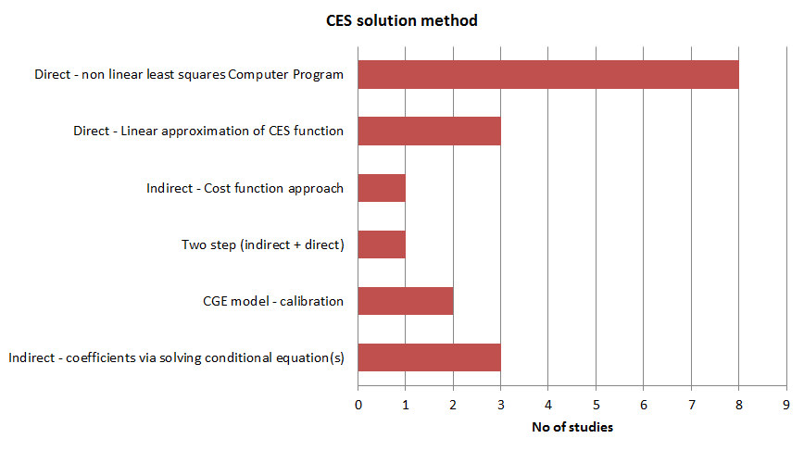

Figure 6: CES solution method in sample papers

### Indirect estimation techniques

In this method, the CES equation is not directly estimated, instead equations are derived from the CES equation which can be estimated by linear process, thereby estimating various parameters of the equation. This is useful when it is intended to estimate only certain parameters. One example when the purpose of the study is to solely estimate the elasticity of substitution, σ, an early CES-based method was to use a “well-known side relation of the CES constant returns to scale production function to estimate sigma.” (76). This is shown in Equation 17, where Q represents net output and L represents labour inputs, which then transforms to the wage relation Equation 18, where q represents the value of net output per worker and w represents earnings per worker. From this, with known data on q and w, σ can then be estimated.

|  |  |
| --- | --- |
|  | Equation |
|  | Equation |

Three early studies include Kotowitz (74), Zarembka (75) and O’Donnell and Swales (76). More recently it has been used as part of the two step process, discussed later.

Van der Werf (32) uses a second technique, based on a cost-function approach to estimate the parameters, via derivation of a system of linear equations based on standard economic assumptions. Koesla and Schymura (43) suggest this helps to “*avoid issues related to Kmenta approximations without having to use cumbersome non-linear estimation procedures”.*

### Direct linear equations

Kmenta’s (138) 1967 linear simplification of the non-linear CES equation is shown in Equation 19. By using a Taylor series expansion, the linear equation is then solvable by Ordinary Least Squares (OLS) techniques.

|  |  |
| --- | --- |
|  | Equation |

### Three studies from our sample used this process: Zarembka (75) in 1970, Duffy and Papageorgiou (83), and Wang (87) in 2012, who states “*The advantage of estimating the above linear model instead of its nonlinear counterpart is that it is more stable numerically*”.Direct non-linear solution

Though linear OLS solutions are numerically easier to calculate, direct non-linear solution via non-linear least squares (NLLS) appears increasingly popular, as evidenced by our sample, where over half the studies used this method (5,43,78–80,83–85). Advocates, such as Koelsa and Schymura (43), are unequivocal, stating “*compared to standard linear estimations using Kmenta approximations, non-linear estimation techniques perform significantly better in this context*.”They extend their critique of linear solutions to cover those who adopted the two step solution, since it first involves linear estimation of σ.

This technique appears a viable and increasingly used option. This would make sense, for several reasons. First, significant econometric guidance now exists for non-linear techniques (e.g (15,139)). Second, a wide spectrum of solution programmes exist, such as the package micEconCES written in R developed by Henningsen and Henningsen (15). Third advances in computing power mean solutions using these programmes are much faster than before 2000.

### Hybrid indirect-direct two step process

This hybrid indirect-direct method is based on Nerlove’s 1967 two-step estimation (140). The first step estimates the elasticity of substitution based on the assumed ratio of marginal productivities, whilst in the second step the value of sigma is inserted back into the CES equation which is then directly estimated. A recent example is Bonga Bonga (82) in 2009.

## The issue of bounded solutionsStatistical testing

### Standard statistical testing

The most common reported statistical testing reports on the fitted function. Tests are aimed at examining how good a ‘fit’ occurs between the left and right hand sides of the aggregate function, i.e. output (Y) versus the function with its econometrically estimated coefficients. Tests also are reported on the individual coefficients. From our sample, the great majority reported these 3 most common tests : the goodness of fit via the correlation coefficient (R2) (e.g.(75,76,79,85); the Durbin-Watson D-W value, d, testing autocorrelation in the residuals of a regression (e.g. (32,74,78,85)); and the t-test on statistical significance of individual coefficients (e.g.(32,78,83,84)). The overall F-test - tests the statistical significance of the overall relationship – was slightly less well reported (e.g.(76,78,82)), but is still considered to be within the scope of standard statistical reporting. Only Easterly and Fischer (79) and Duffy and Papageorgiou (83) reported their analysis included tests and corrections for heteroskedasticity in the error term (fitted residual).

### Other statistical testing

First, cointegration tests in our sample were much less common (than the standard statistical reporting), but help tackle problems such as spurious regression. As Szeto (84) notes three approaches: “*The first approach is to difference the data before estimating. The second approach is to add the lags of the dependent variable. Finally, one may consider using the co-integration technique.”* However none of our sample studies used differenced or lagged variables, and only five used cointegration techniques (all since 2000): Duffy and Papageorgiou (83); Szeto (84); Dissou et al (5); Bonga Bonga (82); and Wang (87). By first conducting tests on the variables (i.e. unit root tests, augmented dickey-fuller (ADF) tests) before proceeding with the analysis, Szeto was able to modify the analysis to use first differences (instead of aggregate values) to correct for autocorrelation problems. Dissou et al (5) followed a similar approach, and finding their data passed the ADF tests on level variables, the latter was appropriate for their analysis.

Second, additional post-statistical testing could improve the study’s results, for example statistical ‘bootstrapping’ resampling of the estimated coefficients - which helps to determine the likelihood that the best solution has been found. Whilst none of our samples used this technique, Raj and Veall ((141) present one of the relatively few studies in wider literature. Another example is the Solow Residual, which could be tested for autocorrelation with the production factors (as considered by Daude (73)).

Third, the assumptions imposed from the literature (which is then taken into the analysis) are rarely tested: e.g. input separability; homotheticity (i.e. ratio of inputs remains the same with output scale); assumed Hicks-neutral technical progress; and unity value for constant elasticity of substitution (though Szeto (84) is an exception).

# Summary and conclusions

This paper set out to discuss - in accessible journal format - the main options and implications of choices involved in setting up and empirically solving energy-augmented CES based MPFs. We reach three major conclusions.

First, the basis for our study is valid: energy augmented CES functions are increasing important, but different assumptions and solution techniques impact on modelling and outturn policies. A lack of consolidated guidance and discussion of the key issues involved with their empirical analysis acerbates this issue. This is the gap that our paper seeks to address.

Second, specifying the parameters and obtaining the fitted solution for the CES function is complex, and involves a myriad of choices, which each have implications on the estimated coefficients. For example, economic output can be measured in constant prices, PPP or per worker, whilst capital, labour and energy all have basic and adjusted values - and though the latter may be more accurate, they are time-consuming to assemble. For the construction of the CES function itself, it seems sensible to report on all nesting options, and to use normalised pre-analysis variables. To solve the non-linear CES equation, there appears a trend towards non-linear solution of the whole equation, possibly due to more off-the-shelf programmes being available coupled to an increase in computing power. However, care needs to be taken, particularly with reviewing solutions and associated statistical testing, since whilst ‘standard’ statistical testing is commonly reported in the empirical CES studies, less common are (pre-analysis) cointegration techniques, bootstrapping resampling of estimated parameters; and testing of underlying assumptions (e.g. returns to scale is unity).

Third, whilst a key advantage in using CES is its flexibility, this flexibility also comes with a warning: the choices made impact on the results. It makes sense – as far as possible – to test restricted and unrestricted models where possible, so that the impact of these choices can be assessed.

Overall, the field of energy-augmented CES-based MPFs is a growing, important field of study, whose results empower macroeconomic models to study future energy use and economic growth, which in turn informs future policy. Since models may be misspecified, with calibrated values that are not appropriate for that model, a wider body supportive work to navigate these the design and solution of these equations issues is vital. We hope this is a small contribution to that effort.

Acknowledgements

We gratefully acknowledge the support of Engineering and Physical Sciences Research Council (EPSRC) and Arup for contributing to the PhD CASE (Collaborative Award in Science and Engineering) scholarship of Paul Brockway. The support of the Economic and Social Research Council (ESRC) is also gratefully acknowledged. The work contributes to the programme of the ESRC Centre for Climate Change Economics and Policy.

References

1. Miller E. An Assessment of CES and Cobb-Douglas Production Functions. US Congr Budg Off Work Pap 2008-05. 2008;

2. Solow RM. Technical Change and the Aggregate Production Function. Rev Econ Stat. 1957;39(3):312–20.

3. Nelson RR. Aggregate Production Functions and Medium-Range Growth Projections. Am Econ Rev. 1964;54(5):575–606.

4. Kander A, Stern DI. Economic growth and the transition from traditional to modern energy in Sweden. Energy Econ. Elsevier B.V.; 2014 Nov;46:56–65.

5. Dissou Y, Karnizova L, Sun Q. Industry-level Econometric Estimates of Energy-capital-labour Substitution with a Nested CES Production Function. Econ Model. 2011;28(6):2832–41.

6. Smyth R, Kumar P, Shi H. Substitution between energy and classical factor inputs in the Chinese steel sector. Appl Energy. Elsevier Ltd; 2011;88(1):361–7.

7. Punt C, Pauw K, Schoor M van, et al. Functional Forms Used in CGE Models: Modelling Production and Commodity Flows. Provid Proj Backgr Pap 20035. 2003;

8. Bor YJ, Huang Y. Energy taxation and the double dividend effect in Taiwan’s energy conservation policy-an empirical study using a computable general equilibrium model. Energy Policy. Elsevier; 2010;38(5):2086–100.

9. Kümmel R, Ayres RU, Lindenberger D. Thermodynamic laws, economic methods and the productive power of energy. J Non-Equilibrium Thermodyn. 2010 Jan;35(2):1–26.

10. Saunders HD. Recent Evidence for Large Rebound: Elucidating the Drivers and their Implications for Climate Change Models. Energy J. 2015;36(1):23–48.

11. Wei T. Impact of energy efficiency gains on output and energy use with Cobb–Douglas production function. Energy Policy. 2007 Apr;35(4):2023–30.

12. Fröling M. Energy use, population and growth, 1800-1970. J Popul Econ. 2011;24:1133–63.

13. Lu Y, Stern DI. Substitutability and the Cost of Climate Mitigation Policy. Energy Procedia. Elsevier B.V.; 2014;61 (2014):1622–5.

14. Saunders HD. Fuel conserving (and using) production functions. Energy Econ. 2008;30:2184–235.

15. Henningsen A, Henningsen G. Econometric Estimation of the “Constant Elasticity of Substitution” Function in R: Package micEconCES. Univ Copenhagen - Inst Food Resour Econ FOI Work Pap 2011/9. 2011;

16. Klump R, Preissler H. CES Production Functions and Economic Growth. Scand J Econ. 2000;102(1):41–56.

17. Shen K, Whalley J. Capital-Labor-Energy Substitution in Nested CES production Functions for China. NBER Work Pap 19104. 2013;

18. Zha D, Zhou D. The elasticity of substitution and the way of nesting CES production function with emphasis on energy input. Appl Energy. Elsevier Ltd; 2014;130:793–8.

19. Temple J. The calibration of CES production functions. J Macroecon. Elsevier Inc.; 2012;34:294–303.

20. Lloyd PJ. The Origins of the von Thünen-Mill-Wiksell-Cobb-Douglas Function. Hist Polit Econ. 2001;33(1):1–19.

21. Cobb C, Douglas P. A theory of production. Am Econ Rev. 1928;18(139-165).

22. Arrow K, Cheney H, Minhas C, Solow R. Capital-Labor Substitution and Economic Efficiency. Rev Econ Stat. 1961;43(3):225–50.

23. Crafts N. Solow and Growth Accounting: A Perspective from Quantitative Economics History. Conf Pap - HOPE Conf Robert Solow Dev Growth Econ Duke Univ April 2008. 2008;

24. Denison EF. The Sources of Economic Growth in the United States and the Alternatives Before Us. Suppl Pap No 13, New York Comm Econ Dev. 1962;

25. Jorgenson DW, Griliches Z. The explanation of productivity change. Rev Econ Stud. 1967;249–83.

26. Chirinko RS. Sigma: The long and short of it. J Macroecon. 2008;30:671–86.

27. Palivos T. Comment on “Sigma: The long and short of it.” J Macroecon. 2008;30:687–90.

28. Groth BC, Gutierrez-domenech M, Srinivasan S. Measuring total factor productivity for the United Kingdom. Bank Engl Q Bull Spring 2004. 2004;63–73.

29. Fernald J, Neiman B. Growth Accounting with Misallocation: Or, Doing Less with More in Singapore. Fed Reserv Bank San Fr - Work Pap 2010-18. 2010;1–49.

30. Chow GC, Li K-W. China’s Economic Growth: 1952 – 2010. Econ Dev Cult Change. 2002;51(1):247–56.

31. Baier SL, Dwyer-Jr GP, Tamura R. How Important Are Capital and Total Factor Productivity for Economic Growth? Fed Bank Reserv Atlanta Work Pap 2002-2a. 2002;

32. Werf E Van Der. Production functions for climate policy modeling: An empirical analysis. Energy Econ. 2008;30:2964–79.

33. Desai P. Total factor productivity in postwar Soviet industry and its branches. J Comp Econ. 1985;9:1–23.

34. Denison EF. Accounting for slower economic growth: the United States in the 1970’s. Brookings Inst Press. 1979;

35. Hulten CR. Total Factor Productivity: A Short Biography. In: Hulten CR, Dean ER, Harper MJ, editors. New Dev Product Anal. Chicago: University of Chicago Press; 2001. p. 1–55.

36. Autor DH, Katz LF, Kearney MS. The polarization of the U.S. labor market. Natl Bur Econ Res Work Pap 11986 Available www.nber.org/papers/w11986. 2006;

37. Long K, Franklin M. Multi–factor productivity: estimates for 1994-2008. Econ Labour Mark Rev. 2010;4(9):67–72.

38. Hájková D, Hurník J. Cobb-Douglas production function: The case of a converging economy. Czech J Econ Financ. 2007;57(9):465–76.

39. Rasch RH, Tatom JA. Energy Resources and Potential GNP. Fed Reserv Bank St Louis Rev June 1977. 1977;10–24.

40. Renshaw EF. Energy efficiency and the slump in labour productivity in the USA. Energy Econ. 1981;3:36–42.

41. Yuan C, Liu S, Wu J. Research on energy-saving effect of technological progress based on Cobb-Douglas production function. Energy Policy. Elsevier; 2009;37(8):2842–6.

42. Capalbo SM, Denny MGS. Testing Long-Run Productivity Models for the Canadian and U.S. Agricultural Sectors. Am J Agric Econ. 1986;68:615–25.

43. Koesler S, Schymura M. Substitution Elasticities in a CES Production Framework. An Empirical Analysis on the Basis of Non-Linear Least Squares Estimations. ZEW Discuss Pap No 12-007. 2012;0–20.

44. Prais Z. A new look at real money balances as a variable in the production function. J Money, Credit Bank. 1975;7(4):535–43.

45. Khan AHA, Ahmad M. Real Money Balances in the Production Function of a Developing Country. Rev Econ Stat. 1985;67(2):336–40.

46. Mishra SK. A Brief History of Production Functions. IUP J Manag Econ. 2010;VIII(4):6–34.

47. Robinson J. The Production Function and the Theory of Capital. Rev Econ Stud. 1953;21:81–106.

48. Fisher FM. The Existence of Aggregate Production Functions. Econometrica. 1969;37(4):553–77.

49. Shaikh A. Laws of Production and Laws of Algebra: The Humbug Production Function. Rev Econ Stat. 1974;56(1):115–20.

50. Felipe J, McCombie JSL. The CES Production Function, the accounting identity, and Occam’s razor. Appl Econ. 2001;33:1221–32.

51. Felipe J, Holz CA. Why do Aggregate Production Functions Work? Fisher’s simulations , Shaikh's identity and some new results. Int Rev Appl Econ. 2001;15(3):261–85.

52. Felipe J, Adams FG. A Theory of Production: the estimation of the Cobb-Douglas Function: A Retrospective View. East Econ J. 2005;31(3):427–45.

53. Kümmel R. Environmental Innovation and Societal Transitions Why energy’s economic weight is much larger than its cost share. Environ Innov Soc Transitions. Elsevier B.V.; 2013;9:33–7.

54. Stern DI. Energy and economic growth in the USA: A multivariate approach. Energy Econ. 1993;15(2):137–50.

55. Bruns SB, Gross C, Stern DI. Is There Really Granger Causality Between Energy Use and Output? Q J IAEE’s Energy Econ Educ Found. 2014;35(4).

56. Kalimeris P, Richardson C, Bithas K. A meta-analysis investigation of the direction of the energy-GDP causal relationship: implications for the growth-degrowth dialogue. J Clean Prod. Elsevier Ltd; 2014 Mar;67:1–13.

57. Feldstein MS. Specification of the Labour Input in the Aggregate Production Function. Rev Econ Stud. 1967;34(4):375–86.

58. Fisk PR. The Estimation of Marginal Product from a Cobb-Douglas Production Function. Econometrica. 1966;34(1):162–72.

59. Hayami Y, Ruttan VW. Agricultural Productivity Differences Among Countries. Am Econ Rev (AER), 60(5), 895 - 911. 1970;60(5):895–911.

60. Ulveling E, Fletcher L. A Cobb-Douglas Production Function with Variable Returns to Scale. Am J Agric Econ. 1970;52(2):322–6.

61. Uri ND. The impact of technical change on the aggregate production function. Appl Econ. 1984;16(4):555–67.

62. Mankiw NG, Romer D, Weil DN. A contribution to the Empirics of Economics Growth. NBER Work Pap No 3541. 1990;

63. Finn MG. Variance properties of Solow’s productivity residual and their cyclical implications. J Econ Dyn Control. 1995;19:1249–81.

64. Dougherty C, Jorgenson DW. International Comparisons of the Sources of Economic Growth. Am Econ Rev. 1996;86(2).

65. Kalirajan KP, Obwona MB, Zhao S. A Decomposition of Total Factor Productivity Growth: The Case of Chinese Agricultural Growth before and after Reforms. Am J Agric Econ. 1996 May;78(2):331–8.

66. Hall RE, Jones CI. Why do some countries produce so much more output per worker than others? Q J Econ. 1999;114(1):83–116.

67. Garcia-Milà T, McGuire TJ. The contribution of publicly provided inputs to states’ economies. Reg Sci Urban Econ. 1992;22:229–41.

68. Kalaitzidakis P, Korniotiis G. The Solow growth model: vector autoregression (VAR) and cross-section times-series. Appl Econ. 2000;32:737–47.

69. Caselli F. Accounting for Cross-Country Income Differences. Cent Econ Perform CEP Discuss Pap No 667. 2005;1–69.

70. Vouvaki D, Xepapadeas A. Total Factor Productivity Growth when Factors of Production Generate Environmental Externalities. Munich Pers RePEc Arch - MPRA Pap No 10237. 2008;1–31.

71. Martin W, Mitra D. Productivity Growth and Convergence in Agriculture versus Manufacturing. Econ Dev Cult Change. 2001;49(2):403–22.

72. The Conference Board. Projecting Global Growth. Economics Working Papers, EPWP #12-02; 2012.

73. Daude C. Understanding Solow Residuals in Latin America. Economia. 2014;13(2):109–38.

74. Kotowitz Y. Capital-Labour Substitution in Canadian Manufacturing 1926-39 and 1946-61. Can J Econ. 1968;1(3):619–32.

75. Zarembka P. On the empirical relevance of CES Production Function. Rev Econ Stat. 1970;52(1):47–53.

76. O’Donnell AT, Swales JK. Factor Substitution, the C.E.S. Production Function and U.K. Regional Economics. Oxf Econ Pap. 1979;31(3):460–76.

77. Desai P, Martin R. Efficiency Loss From Resource Misallocation in Soviet Industry. Q J Econ. 1983;98(3):441–56.

78. Rusek A. Industrial Growth in Czechoslovakia 1971-1985: Total Factor Productivity and Capital-Labor Substitution. J Comp Econ. 1989;13:301–13.

79. Easterly W, Fischer S. The soviet economic decline. World Bank Econ Rev. 1995;9:341–71.

80. Kemfert C. Estimated substitution elasticities of a nested CES production function approach for Germany. Energy Econ. 1998;20:249–64.

81. Gohin A, Hertel T. A note on the CES functional form and its use in the GTAP model. GTAP Res Memo No 2 Available https//www.gtap.agecon.purdue.edu/resources/download/1610.pdf. 2001;

82. Bonga-Bonga L. The South African Aggregate Production Function: Estimation of the Constant Elasticity of Substitution Function. South African J Econ. 2009;77(2):332–49.

83. Duffy J, Papageorgiou C. A Cross-Country Empirical Investigation of the Aggregate Production Function Specification. J Econ Growth. 2000;5(March 2000):87–120.

84. Szeto KL. An Econometric Analysis of a Production Function for New Zealand. New Zeal Treas Work Pap 01/31. 2001;

85. Kemfert C, Welsch H. Energy-Capital-Labor Substitution and the Economic Effects of CO2 Abatement. J Policy Model. 2000;22(6):641–60.

86. Cantore C, Levine P, Yang B. CES Technology and Business Cycle Fluctuations. Univ Surrey Discuss Pap 2014/DP04-14. 2014;

87. Wang Y. Estimating CES Aggregate Production Functions of China and India. Conf Proc 4th World Conf - Appl Econ Bus Dev 2012. 2012;

88. Bosetti V, Carraro C, Galeotti M, Massetti E, Tavoni M. WITCH: A World Induced Technical Change Hybrid Model. Work Pap Dep Econ Univ Venice No 46/WP/2006. 2007;

89. Sancho F. Calibration of CES Functions for Real-World Multisectoral Modeling. Econ Syst Res. 2009;21(1):45–58.

90. Sajadifar S, Arakelyan A, Khiabani N. The Linear Approximation of the CES Function to parameter estimation in CGE Modeling. Conf Proc Int Conf Bus Econ Res 2010. 2010;1–10.

91. Klump R, Saam M. Calibration of Normalised CES Production Functions in Dynamic Models. ZEW Discuss Pap No 06-078. 2006;

92. Annabi N, Cockburn J, Decaluwe B. Functional Forms and Parametrization. MPIA Work Pap 2006-04.

93. C. Sanchez. Chapter 7 - Calibration, Solution and Validation of the CGE Model. Rising Inequal Falling Poverty Costa Rica’s Agric Dur Trade Reform A Macro-Micro Gen Equilib Anal. Maastrict: Shaker; 2004. p. 189–226.

94. Turner K. Negative rebound and disinvestment effects in response to an improvement in energy efficiency in the UK economy. Energy Econ. Elsevier B.V.; 2009 Sep;31(5):648–66.

95. La Grandville O de., Solow RM. Capital-labour substitution and economic growth. Econ Growth A Unified Approach Cambridge Univ Press Chapter 5. 2009;

96. Guo JT, Lansing KJ. Capital-labour substitution and equilibrium indeterminacy. J Econ Dyn Control. 2009;33(12):1991–2000.

97. Koetse MJ, de Groot HLF, Florax RJGM. Capital-energy substitution and shifts in factor demand: A meta-analysis. Energy Econ. 2008;30:2236–51.

98. Ravel D. Estimation of a CES Production Function With Factor Augmenting Technology. US Cent Econ Stud Work Pap 11-05. 2011;1–58.

99. Klump R, Mcadam P, Willman A. The Normalised CES Production Function: Theory and Empirics. Eur Cent Bank Work Pap 1294. 2011;

100. Schreyer P. Capital Stocks, Capital Services and Multi-factor Productivity Measures. OECD Econ Stud. 2004;(37):163–84.

101. Growiec J. On the measurement of technological progress across countries. Natl Bank Pol Work Pap No73. 2010;

102. Hunt LC, Evans ‎Joanne. International Handbook on the Economics of Energy. Available at https://books.google.co.uk/books?isbn=1849801991. 2011;

103. Cardenete MA, Guerra ‎Ana-I, Sancho ‎Ferran. Applied General Equilibrium: An Introduction. Available at https://books.google.co.uk/books?isbn=3642247466. 2012;

104. Kreinin ME, Plummer ‎Michael G. The Oxford Handbook of International Commercial Policy. Available at https://books.google.co.uk/books?isbn=0195378040. 2012;

105. Inklaar R, Timmer MP. Capital, labor and TFP in PWT8.0. Groningen Growth Dev Cent - Tech Rep. 2013;1–38.

106. HM Revenue and Customs. HMRC’s CGE model documentation. Available at https://www.gov.uk/government/uploads/system/uploads/attachment_data/file/263652/CGE_model_doc_131204_new.pdf. 2013;

107. Kim J. Monetary Policy in a Stochastic Equilibrium Model with Real. Available at www.federalreserve.gov/pubs/feds/1998/199802/199802pap.pdf. 1998;

108. Kincai GR. Adjustment Dynamics in the Euro Area: A Fresh Look at the Role of Fiscal Policy Using a DSGE Approach. Eur Comm Econ Pap 322 Available http//ec.europa.eu/economy_finance/publications/publication12596_en.pdf. 2008;

109. Felipe J, Fisher FM. Aggregation in Production Functions: What Applied Economists should know. Metroeconomica. 2003;54(2&3):208–62.

110. Edenhofer O, Bauer N, Kriegler E. The impact of technological change on climate protection and welfare: Insights from the model MIND. Ecol Econ. 2005;54(2-3):277–92.

111. Lecca P, Swales K, Turner K. An investigation of issues relating to where energy should enter the production function. Econ Model. Elsevier B.V.; 2011;28(6):2832–41.

112. Stern DI. The role of energy in economic growth. Ann N Y Acad Sci. 2011 Feb;1219:26–51.

113. Guarda P. A Production Function for Luxembourg: estimating a CES function. CRP-CU mod-L2 Work Pap. 1997;

114. Sun Q. Technology Change for a two-level CES production function: an empirical study for Canada. Ottawa, Ontario; 2012.

115. Department of Energy & Climate Change (DECC). Energy Consumption in the UK: 2013 update [Internet]. 2013. Available from: http://www.decc.gov.uk/en/content/cms/statistics/publications/ecuk/ecuk.aspx

116. British Petroleum (BP) Ltd. Statistical Review of World Energy 2014 [Internet]. 2014. Available from: http://www.bp.com/content/dam/bp/excel/Energy-Economics/statistical-review-2014/BP-Statistical_Review_of_world_energy_2014_workbook.xlsx

117. International Energy Agency (IEA). “Extended world energy balances”, IEA World Energy Statistics and Balances (database) [Internet]. 2013. Available from: http://www.oecd-ilibrary.org/energy/data/iea-world-energy-statistics-and-balances/extended-world-energy-balances_data-00513-en

118. Paquet A, Robidoux B. Issues on the measurement of the Solow residual and the testing of its exogeneity: Evidence for Canada. J Monet Econ. 2001 Jun;47(3):595–612.

119. Nilsen Ø a., Raknerud A, Rybalka M, Skjerpen T. The importance of skill measurement for growth accounting. Rev Income Wealth. 2011;57(4997):293–305.

120. Berndt ER. Energy use, technical progress and productivity growth: A survey of economic issues. J Product Anal. 1990;2(1):67–83.

121. Stern DI. Energy quality. Ecol Econ. Elsevier B.V.; 2010 May;69(7):1471–8.

122. Warr B, Ayres R, Eisenmenger N, Krausmann F, Schandl H. Energy use and economic development: A comparative analysis of useful work supply in Austria, Japan, the United Kingdom and the US during 100years of economic growth. Ecol Econ. Elsevier B.V.; 2010 Aug;69(10):1904–17.

123. Burda MC, Severgnini B. Solow residuals without capital stocks. J Dev Econ. Elsevier B.V.; 2014 Jul;109(October 2013):154–71.

124. Wallis G, Oulton N. Integrated Estimates of Capital Stocks and Services for the United Kingdom: 1950-2013. Pap Prep IARIW 33rd Gen Conf Rotterdam, Netherlands, August 24-30, 2014. 2014;

125. Inklaar R. The sensitivity of capital services measurement: Measure all assets and the cost of capital. Rev Income Wealth. 2010;56(2):389–412.

126. Barro R, Lee J. International data on educational attainment: updates and implications. Oxf Econ Pap. 2001;53(3):541–63.

127. Da Silva EG. Capital services estimates in Portuguese industries, 1977-2003. Port Econ J. 2010;9(1):35–74.

128. Warr BS, Ayres RU. Evidence of causality between the quantity and quality of energy consumption and economic growth. Energy. Elsevier Ltd; 2010;35(4):1688–93.

129. Sorrell S. Energy Substitution, Technical Change and Rebound Effects. Energies. 2014 Apr 29;7(5):2850–73.

130. Jacoby HD, Reilly JM, McFarland JR, Paltsev S. Technology and technical change in the MIT EPPA model. Energy Econ. 2006;28(5-6):610–31.

131. Chang K-P. Capital-energy substitution and the multi-level CES production function. Energy Econ. 1994;16(1):22–6.

132. Prywes M. A nested CES approach to capital-energy substitution. Energy Econ. 1986;8(1):22–8.

133. Thompson H. The applied theory of energy substitution in production. Energy Econ. 2006;28(4):410–25.

134. Adetutu MO. Energy efficiency and capital-energy substitutability: Evidence from four OPEC countries. Appl Energy. Elsevier Ltd; 2014;119:363–70.

135. Honma S, Hu J-L. Total-factor energy productivity growth of regions in Japan. Energy Policy. Elsevier; 2009 Oct;37(10):3941–50.

136. Cantore C, Levine P. Getting normalization right: Dealing with “dimensional constants” in macroeconomics. J Econ Dyn Control. Elsevier; 2012;36(12):1931–49.

137. Manne A, Mendelsohn R, Richels R. MERGE. A model for evaluating regional and global effects of GHG reduction policies. Energy Policy. 1995;23(1):17–34.

138. Kmenta J. On Estimation of the CES Production Function. Int Econ Rev (Philadelphia). 1967;8(2):180–9.

139. Greene W. Chapter 7 - Nonlinear, semiparametric and nonparametric regression models. Econom Anal - 7th Ed. 2010.

140. Nerlove M. Recent empirical studies of the CES and related production function. In: Brown M, editor. Theory Empir Anal Prod. New York: NBER and Columbia University Press; 1967.

141. Raj B, Veall MR. The energy-capital complementarity debate: An example of a bootstrapped sensitivity analysis. Environmetrics. 1998;9:81–92.

Appendix A: sample set of macroeconomic production functions used for empirical analysis

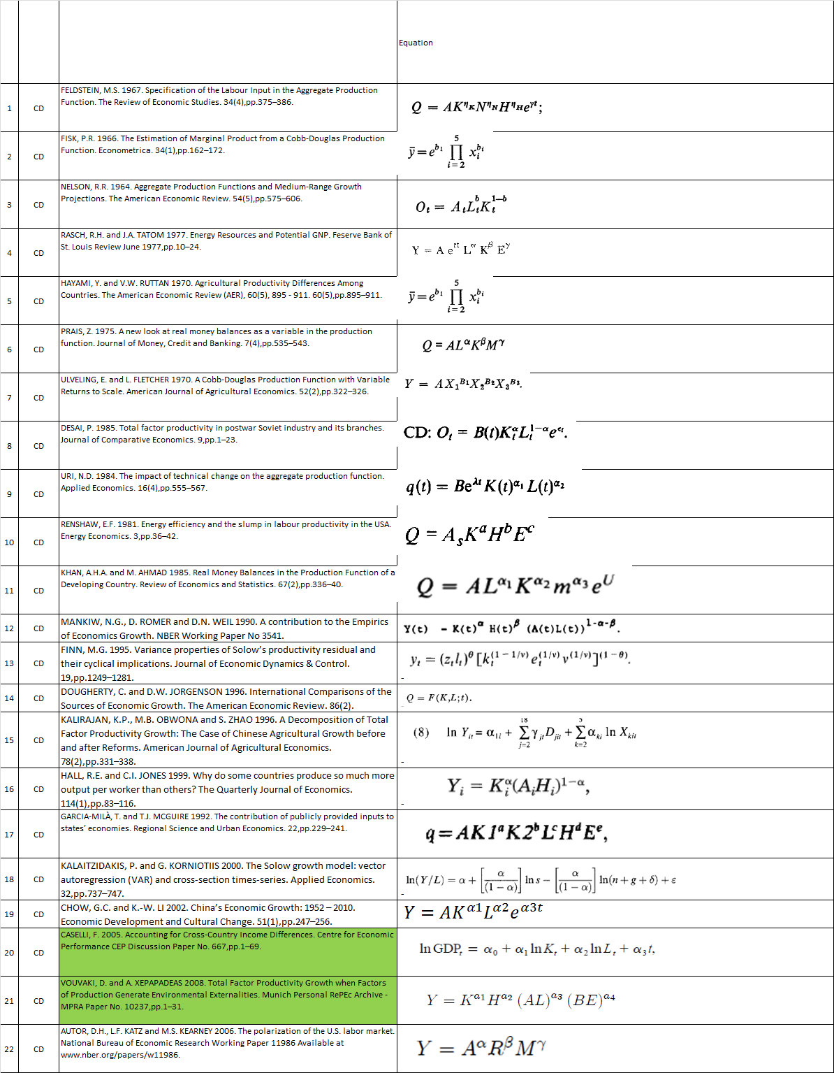

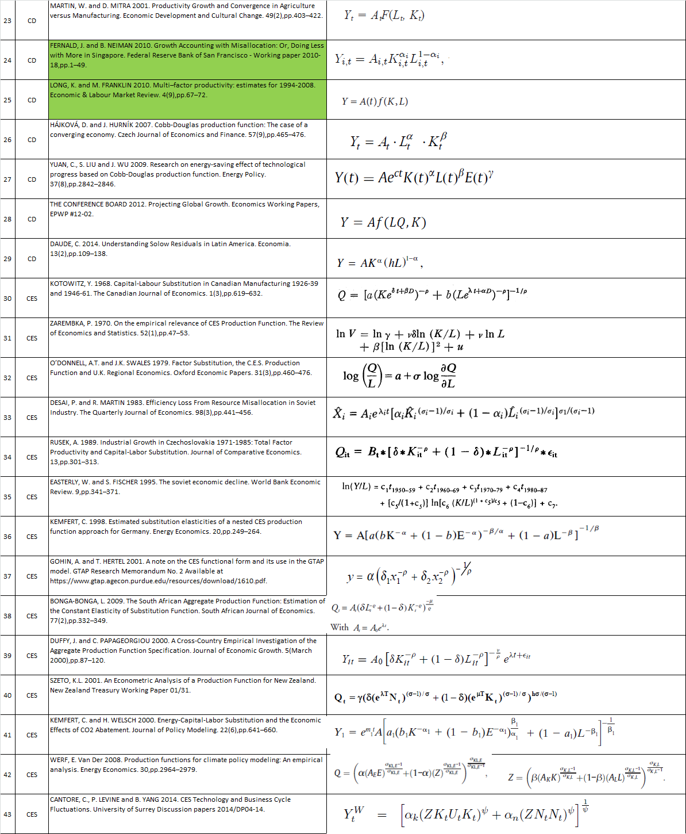

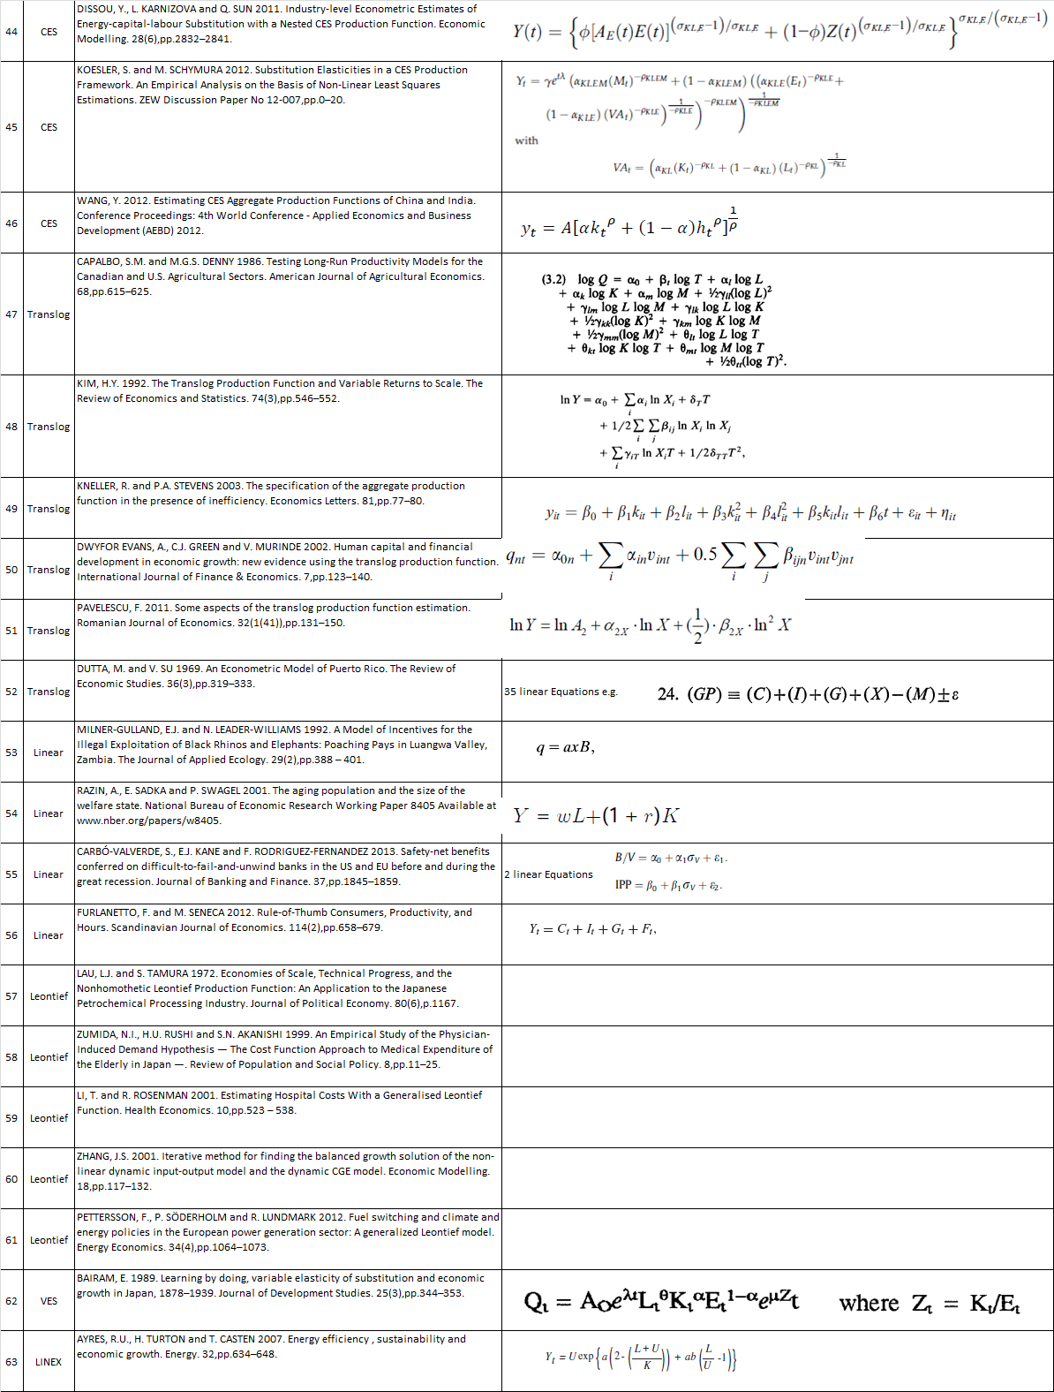

Appendix A2: sample studies

The Google-Scholar results are displayed based on relevance, and so the results were reviewed following those return results, and selecting appropriate empirical studies. Thus the aim was to provide a representative sample as possible of the larger pool of published work, as show below.

Table A1: Empirical Production function studies, by decade

|  |  |  |  |  |  |  |  |
| --- | --- | --- | --- | --- | --- | --- | --- |
| **Production Function** | **Decade** | | | | | | **Total** |
| **1960-1969** | **1970-1979** | **1980-1989** | **1990-1999** | **2000-2009** | **2010-2015** |
| C-D | 3 | 4 | 4 | 6 | 10 | 2 | 29 |
| CES | 1 | 2 | 2 | 2 | 6 | 4 | 17 |
| Translog |  |  | 1 | 1 | 1 | 2 | 5 |
| Linear | 1 |  |  | 1 | 1 | 2 | 5 |
| Leontief |  | 1 |  | 1 | 1 | 2 | 5 |
| VES |  |  | 1 |  |  |  | 1 |
| Linex |  |  |  |  | 1 |  | 1 |
| **Total** | **5** | **7** | **8** | **11** | **20** | **12** | **63** |

To test this, we used a similar search in IDEAS/REPEC and Science-Direct databases[3]. Table 1 shows the results, which confirm the ascendancy of the CD and CES functions (with Translog a notable third). However, only partial support is found for the assertion that the CES function is increasingly used versus CD function, since the number of CES papers are around half those of CD function for 2006-2015. Yet this conflict with the Google Scholar search may actually be due the fact Google Scholar encompasses a much wider search area: and so picks up much more of the practical reports using CES (e.g.(29,81,99)) rather than the more academic returns of the IDEAS-REPEC and Science Direct databases.

Table 1: search results for production function references from IDEAS-REPEC and Science Direct databases

|  |  |  |  |  |  |  |  |  |
| --- | --- | --- | --- | --- | --- | --- | --- | --- |
| Function | 1900-2005 | | 2006-2015 | | Total | | % 2006-2015 | |
| IDEAS - REPEC | Science Direct | IDEAS - REPEC | Science Direct | IDEAS - REPEC | Science Direct | IDEAS - REPEC | Science Direct |
| CD | 182 | 56 | 254 | 73 | 436 | 129 | 58% | 57% |
| CES | 56 | 26 | 125 | 44 | 181 | 70 | 69% | 63% |
| VES | 5 | 1 | 1 | 3 | 6 | 4 | 17% | 75% |
| Linex | 0 | 2 | 4 | 2 | 4 | 4 | 100% | 50% |
| Translog | 71 | 26 | 67 | 22 | 138 | 48 | 49% | 46% |
| Linear | 16 | 6 | 20 | 6 | 36 | 12 | 56% | 50% |
| Leontief | 3 | 2 | 17 | 3 | 20 | 5 | 85% | 60% |
| **Total / Average** | **333** | **119** | **488** | **153** | **821** | **272** | **59%** | **56%** |

Characteristics of sample studies

Second, Appendix A2 shows the most common variables to be constant price GDP, labour hours and capital stock. Quality adjusted labour occurred in a third of studies, with quality adjusted capital (e.g. capital services) comprising around 20% of studies. Only 15% of sample studies used energy-augmentation, but those that do involve different quantifications (i.e. quality adjustments) of energy, i.e. thermal energy, Exergy, Useful Work, price adjusted primary energy. Agricultural production factors (land, fertiliser, feed) were also included in around 15% of the sample papers. Third, it is interesting to compare the evolution of solution techniques for the sample set linear OLS, linear other, non-linear, as shown in Appendix A2. We can see that simple OLS solution is most common for CD function, though in around half the CD cases the direct calculation of the Solow residual was estimated. For the CES function, there was a mix of solution techniques between direct and indirect evaluation of the coefficients from the CES function itself.

Fourth, Appendix A2 shows the key method of calibrating the key variables – which is crucial since it influences the outcome of the study. For the output share (e.g. Capital (α) and Labour (β)), the use of regression occurs three times as often as by factor share, the historical basis for calibration. For the estimating the elasticity of substitution, for CES most use econometric methods. Fifth, the scale and temporal aspects of our sample set is interesting to consider, as shown in Appendix A2.. Most common is the analysis of a single country, over a given time-series. Cross-sectional data was rarely analysed in our sample. Add some discussion here: is there a change over time?

Lastly, for residuals and statistical testing, the results were revealing, as shown in Appendix A2 The Solow Residual was only calculated in 25% of the studies, and within that group there was no statistical testing of the Solow Residual. For the fitted residual (i.e. error from the estimated function to actual output) none of the studies had undertaken a statistical analysis of the residual itself.

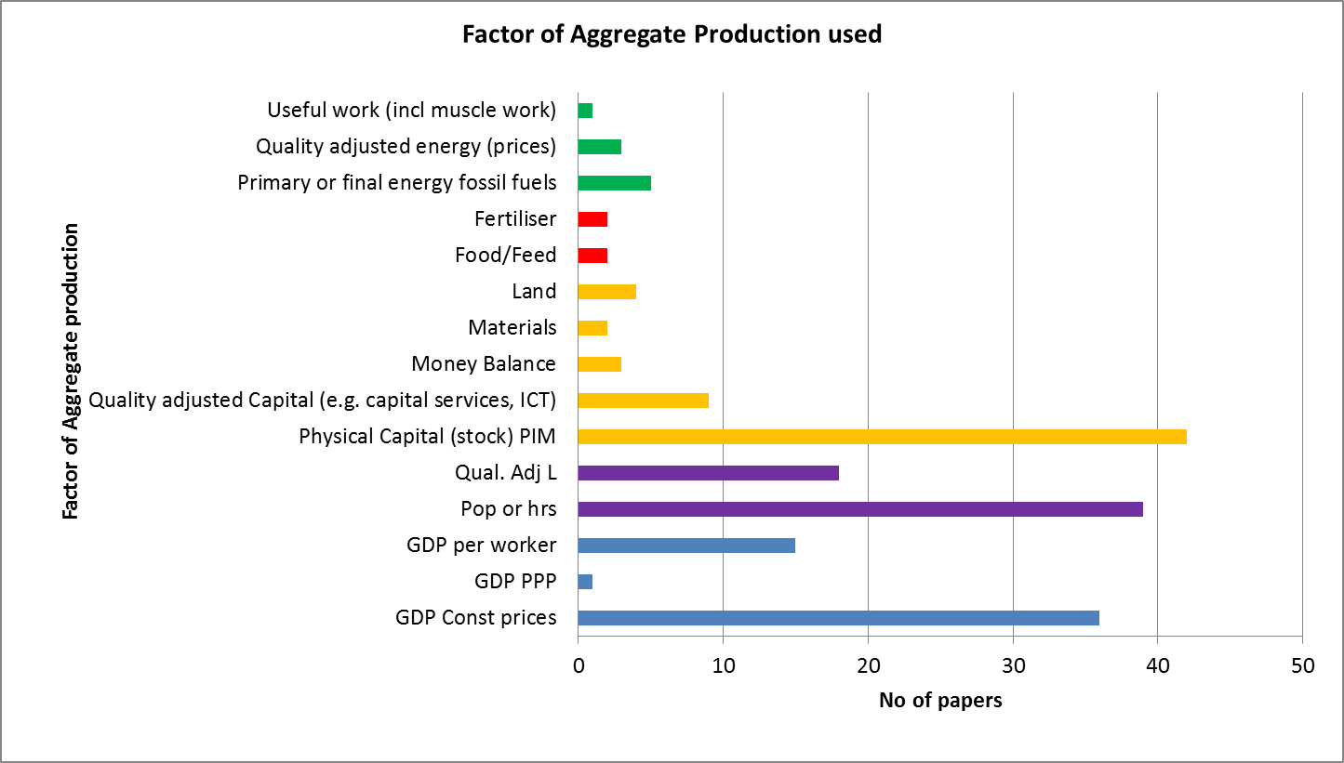

Figure 5: factors of production used in sample papers science direct

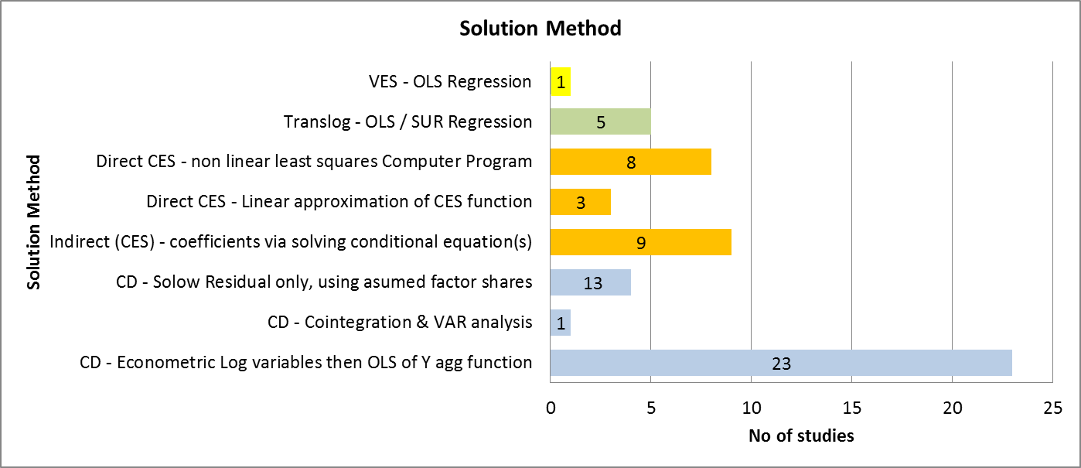

Figure 6: Solution method in sample studies yes add decade data 1960-1970 etc could make stacked bars, e.g. 1960-1970 has 8 linear OLS but 1 by 2000-2010. So this might pick up time trend

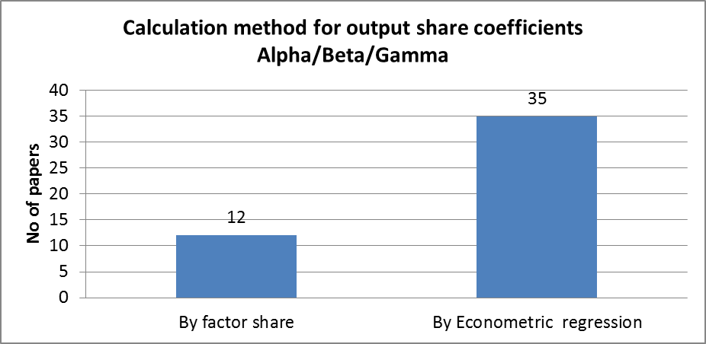

Figure 7: Calculation method for coefficients Alpha and Beta in sample studies yes add decade data 1960-1970 etc could make stacked columns, so 1960-1970 have 5 factor share but 1 by 2000-2010.

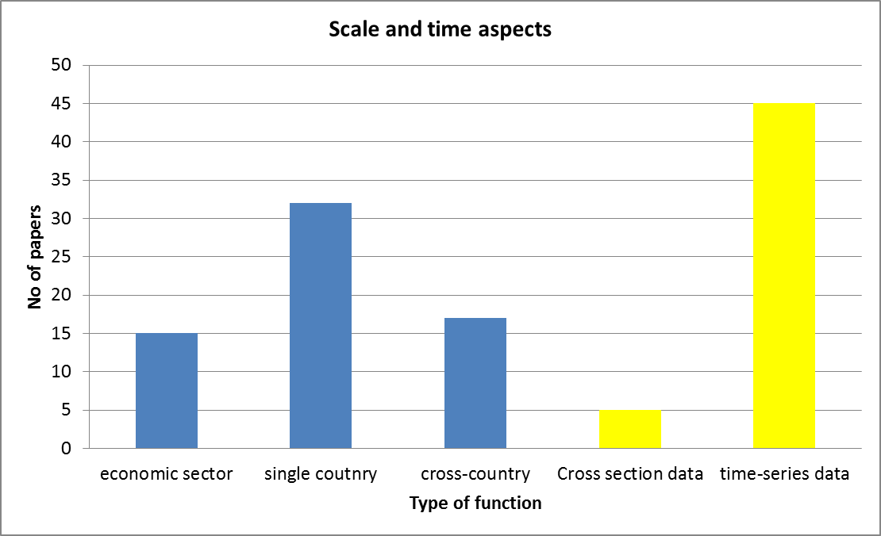

Figure 8: Scale and time aspects in sample studies Add decadal parts via stacked bars?

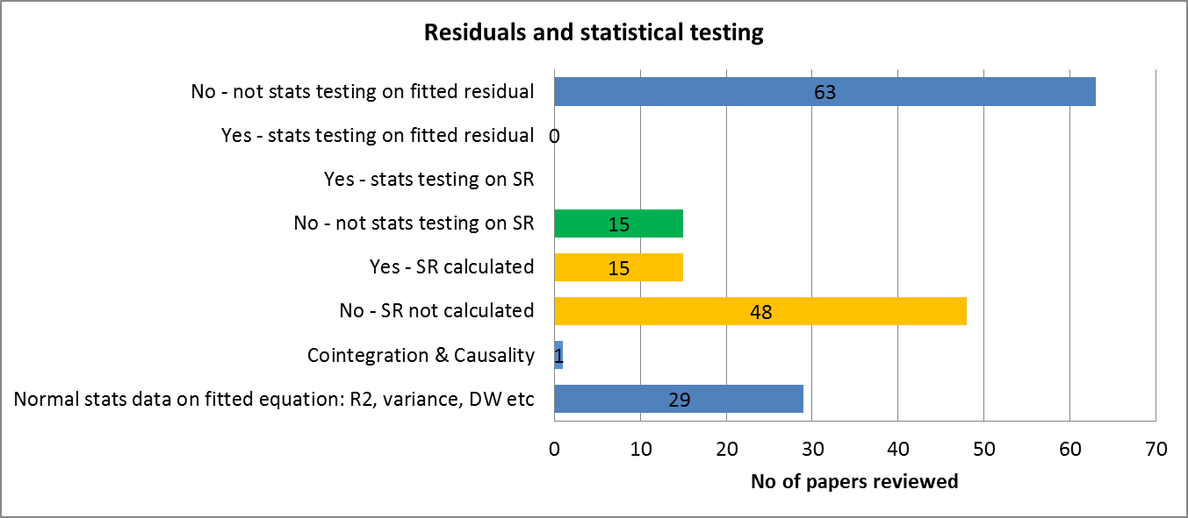

Figure 9: residuals and statistical testing in studies reviewed add decade data 1960-1970 no – describe SR in main text as only the last two bars that are interesting by decade. Add a row: do the papers look at precision of how to estimate the coefficients. Uncertainty of the fitted parameters.

## What does this all mean?

Based on sample studies and the wider literature reviewed earlier, there are some interesting observations and trends worth discussing here, since they are relevant for the next section. First, capital (stock, based on PIM method) and labour (gross hours) remain the key production factors included. However, quality adjustment of both labour (i.e. based on schooling ref) and capital (i.e. capital services ref, or use of ICT ref) are also important. For other variables, historically, agricultural variables such as land, machinery and fertiliser were more commonly included (ref). Energy seems to be playing a more important role in recent studies, and is used embedded in CGE models (ref) and policy studies (ref)**.**

Second, the importance to policy of the elasticity of substitution and the Solow Residual is being increasingly recognised (e.g.(1,43,129)) , but as Koesla (43) recently notes*“ so far only few consistent estimates of elasticities exist”.*

1. Google Scholar search 05 March 2015 excluding citations for 7 common types of production function: “CES production function”; “Cobb-Douglas Production function”; “Linear production function”; “Translog production function”; “Leontief production function”; “VES production function”; “LINEX production function”.
2. <http://www.euklems.net/>; <http://www.wiod.org/new_site/database/seas.htm>; <http://www.rug.nl/research/ggdc/data/10-sector-database>
3. IDEAS-REPEC and Science-Direct search 12 March 2015 in abstract-title-keywords for “CES production function”; “Cobb-Douglas Production function” etc.